**Steps to Apply for a Substitute Authorization**

**(You must be 18 years old to apply)**

Updated on 7/11/23

**Items that will need to be uploaded into your online application:**

* Official college transcripts indicating at least 60 college credits or an AA degree.
  + The credits must be from an accredited college or university
  + You can check the accreditation status of your school on the DAPIP website in this link: <https://ope.ed.gov/dapip/#/home>
  + If you completed your college credits out of the country your transcript will need a program evaluation completed by an agency who is a NACES member.
    - A course by course evaluation is not required. A degree or credit evaluation is acceptable.
    - NACES evaluation agency members may be found on this website: <http://www.naces.org/members.html>
  + **Please note: if you hold a Paraeducator Certification, but do not have college credits, you will need to apply to add a concentration to your Paraeducator Certification.** 
    - It is a different application than the Substitute Authorization.
    - Do not apply for the Substitute Authorization.
    - Instructions are included in an indicated section below
* Official AEA transcript for the substitute authorization course.
  + **We do not ACCEPT Certificate of Completions from the AEA.**
  + If you are completing a teacher preparation program, we will also accept a letter from your college verifying you have met the substitute authorization course requirements. This letter should be uploaded in place of the substitute authorization course. (see document below for outline*)
  + We can also waive the course if you have student teaching cited on your transcripts. Please upload a word document indicating this in place of the required substitute authorization course.

**Additional steps that need to be taken:**

* Fee Payment
  + The application fee is $120 dollars if you have never held a license with the BoEE.
* All new applicants will need a full background check.
  + Beginning June 5th, 2023, the Board of Educational Examiners will be using Fieldprint to complete the federal portion of our required background checks for new applicants.
  + Fieldprint has locations across Iowa to allow individuals applying for their first license with the Board of Educational Examiners to be fingerprinted and have their prints submitted to the federal agency to complete this portion of the background check.
    - Within each application will be [**instructions**](https://iowaboee.my.salesforce.com/sfc/p/t0000000LBEA/a/8y000004RYCZ/iknda5QZF9cqLZK6xKw9Fe8TRiXWW0hPVDZmOaxmPPc) to outline the procedures to make an appointment, secure fingerprints and submit the necessary information.
  + Individuals applying for licensure who live outside of Iowa have two options.
    - You may wait until you come to Iowa and complete the process through Fieldprint. We are receiving the final reports within one week for the majority of submissions.
    - You may also contact our office (515-281-3245) to request a card packet be mailed to you. There will be an additional fee added to your application, but no additional fee will be required with Fieldprint.
  + As a reminder, if you already have a license (Coaching Authorization, Paraeducator Certification etc.) you will **NOT** need a background check again as long as the license was issued after October of 2000.

The application process can take 4-6 weeks from when we have a completed application. A complete application will include the following:

* Fees paid
* Official College transcripts
* Official Substitute Authorization transcripts
* Fingerprint cards mailed to the BoEE -or- completed at the BoEE

Please do not call for status checks as it does slow down the processing of licenses.

* + If your application has not been issued in 4-6 weeks from the time you sent your fingerprints please contact us.
  + For specific questions on the application process or further guidance on completing the application please contact Greg Horstmann at (515) 281-3587 or Meredith Hawk at (515) 725-2146

**How to submit an application for a Substitute Authorization:**

The entire application process is completed online and can be found on the Iowa BoEE website.

* Use the following link to set up an account or log into your existing account. <https://boee.iowa.gov/you-begin>
  + The application system began in March of 2019. If you already have an account you will need to log into your account.
    - Click on I Agree (**create an Account**) if you have never held a license with the BOEE or not used this new system. (system started 3/18/2019).
    - Click on “I agree (**continue to log in**) if you have already set up an account after 3/18/2019.
* You will need to click on New Application or Renew



* Verify the information on the next two pages. Click next to move to the next page.
* Click on Apply for a new license.

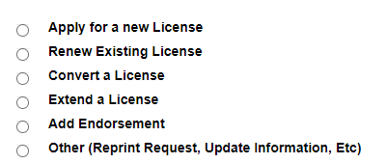

* Click on Substitute in the pull-down menu.
* Click on *Substitute Authorization (use only if you have not completed a teacher prep program)*
  + If you’re in a teacher prep program but have not yet graduated or passed praxis this is the correct application.
* The next screen will indicate you are about to create the application click on next to continue.
* The first Item you will need to complete is the Checklist. You will not be able to complete any other section until you complete the checklist.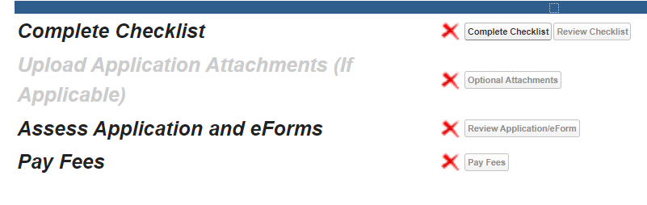
* Once you complete the checklist the Red X will turn to a Green Checkmark.
* You will upload all official transcriptswhere it says upload application attachments.
  + Any Item that has a Blue Checkmark in the required box must be uploaded.
    - If you make a mistake you can always use the **ADD MORE** button at the bottom of the page to upload additional documents.
    - Keep in mind only OFFICIAL transcripts are accepted.
* Once you have uploaded the required documents the Red X will turn to a Green Checkmark.
* You will then need to click on **Pay Fees** and submit your payment.
  + Please make sure everything is accurate as ALL FEES ARE NON-REFUNDABLE.
  + Once you have paid the fee the Red X will turn to a Green Checkmark
* Once the fee is paid you will click on **Review** application to submit.

**How to add a Substitute Authorization to a Paraeducator Certification:**

Follow the instructions above for logging in to your account with the BoEE and creating a new application.

* Start a "New Application" and click **Next**
* Click on Click on*Add Endorsement*and click **Next**
* From the drop down menu choose *Add concentration para* and click on **Next**
* Finally you select your Para Certification you want the endorsement added to.
* In the "Review Application" section, you will include information for the recommending official from the entity you completed the Sub Auth preparation.
* We provide the email address for all recommending officials from the AEA's in that section.

**Document to submit from college in lieu of Substitute Authorization transcript.**

This document can be copied and uploaded in place of the official substitute authorization transcript to verify courses that meet the substitute authorization requirements.

Please indicate what classes you have completed that meet the following requirements. Please also include the course name, course number and a course description for each class as they relate to the requirements below.

1. Classroom management. This component includes an understanding of individual and group motivation and behavior to create a learning environment that encourages positive social interaction, active engagement in learning, and self-motivation.

2. Strategies for learning. This component includes understanding and using a variety of learning strategies to encourage students’ development of critical thinking, problem solving, and performance  
skills.

3. Diversity. This component includes understanding how students differ in their approaches to learning and creating learning opportunities that are equitable and are adaptable to diverse learners.

4. Ethics. This component includes fostering relationships with parents, school colleagues, and organizations in the larger community to support students’ learning and development and to be aware of the board’s rules of professional practice and competent performance.